Curriculog User Guide
Last updated: 8/22/19 by K. Heese
Contents
Accessing Curriculog 1
Starting a New Proposal 1
Finding and Opening an Existing Proposal 2
Using Tabs to Find Proposals 2
Using Advanced Filter to Find Proposals 2
Opening a Proposal 4
Attaching a File 4
Adding a Comment 5
Making a Decision 5
Custom Routing 7

Pro tip: you can Ctrl+click on any of the section titles above to go directly to that section.

Accessing Curriculog
HSU employees can access Curriculog at https://humboldt.curriculog.com/ or through the myHumboldt Portal, on the Faculty/Staff Resources tab by clicking on the Curriculog pagelet towards the bottom of the screen:
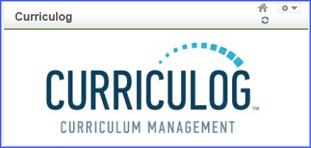

Once you’ve accessed Curriculog, you’ll need to click the Login link in the upper right corner in order to view or create proposals. This will log you in using HSU’s single sign-on. If you experience difficulties logging in, please contact the Curriculum Coordinator at ext 4193 or Kristin.heese@humboldt.edu.

Starting a New Proposal
Click the button near the upper left of the screen to start a New Proposal:
This will open up a new page, listing the available proposal form types. Choose the appropriate form for your proposal: Course Change Form, New Course Form, New Program Form, or Program Change Form.

Please keep in mind: if you’re proposing a new course or making a course change that affects required or optional classes for your program (i.e., a change in courses that are applicable to a degree that would need to be listed in the HSU Catalog), you’ll also need to submit a Program Change Form to accompany your course proposal(s). If you have any questions about which proposal form(s) to submit, please contact the Curriculum Coordinator at ext 4193 or Kristin.heese@humboldt.edu.

To begin your proposal, click on the row for the desired form, and then click on the check mark in the blue circle to Start Proposal.
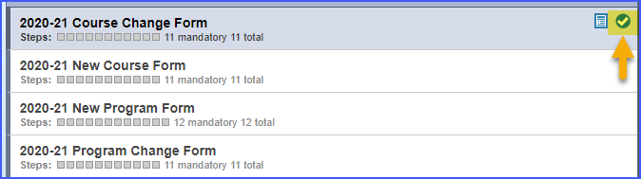

This will open up the proposal form. Please read through the Instructions area at the top, and follow the instructions to complete, launch, and approve your proposal.

Click here to return to Table of Contents.

Finding and Opening an Existing Proposal

Using Tabs to Find Proposals
Once you’ve logged in to Curriculog (see this section for instructions on logging in, if needed), you can use the tabs towards the top left of the screen to help you find proposals:

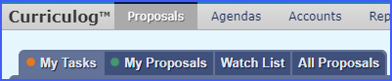
- My Tasks shows proposals that are awaiting your decision, such as proposals needing your approval as Department Chair or Associate Dean, and proposals that currently reside on a committee approval step in which you participate (such as steps involving the Integrated Curriculum Committee or subcommittees, or the University Senate).
- My Proposals only shows proposals that you entered as the Originator. Regardless of which approval step your proposal is at, your entered proposals will always show up here.
- Watch List shows proposals you’ve chosen to watch. You can add proposals to this list by clicking the proposal’s Star Icon.
- All Proposals is exactly like it sounds: it lists out every proposal that’s ever been entered into Curriculog.

Click here to return to Table of Contents.

Using Advanced Filter to Find Proposals
This is probably the most efficient way to find proposals.
- If you know for sure that the proposal you’re looking for is awaiting your (or your committee’s) approval, you can look for it on the My Tasks tab.
- If you’re not sure which step the proposal is at, we recommend starting in the All Proposals tab.
While in either My Tasks or All Proposals, click on the Advanced Filter link in the upper left corner.
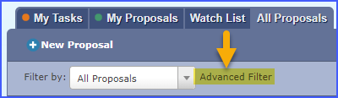

In the Advanced Filter area, you can choose from a variety of options. Here are some of the most useful:
- Found Under: You can select a particular College or Department to find proposals. If you’re searching by College, be sure to click the check box for “Include all child entities under my selection” otherwise your search likely won’t return any results.
- Current Step Name: if you know for sure which approval step your proposal is on (i.e., if it’s with University Senate or the Academic Master Planning [AMP] Subcommittee, for instance) or if you’re on a committee and want to see all proposals up for review, you can use this drop-down to find proposals currently on the specified step.
- Proposal Status Checkboxes: unless it’s already been completed, 99% of all proposals are listed under the “Active” type; if you’re trying to find proposals currently working their way through the approval process, limit your search to Active only and uncheck the other boxes to narrow your search results. Exceptions: if the Curriculum Office is waiting for additional documentation, you might see a proposal on “Held” status, and withdrawn proposals have a status of “Cancelled”.
After you’ve selected your desired options, click the Filter Proposals button. If you’re not finding the expected results, feel free to alter your filter parameters and try again!

Pro tip: we recommend changing the number of proposals displayed on a page to Show 50 results to limit the number of pages you need to scroll through.
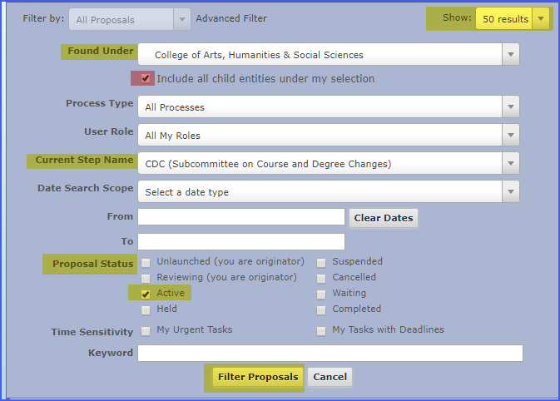

Opening a Proposal
Once you see your desired proposal in the list, click on its row. You’ll see a series of button images appear to the right of the proposal name. Click on the button that looks like a piece of paper to Edit Proposal or View Proposal, and detailed proposal information will appear on a new page.

Note: if the proposal is currently awaiting your approval or your committee’s approval, you’ll see the Edit Proposal option. If the proposal isn’t on one of your approval steps, you can only View Proposal.

Click here to return to Table of Contents.

Attaching a File
In order to attach a file, the proposal will need to be on approval step involving you. How do you know if the proposal is on one of your steps? Here are some ways to tell:
- The proposal will show up in the My Tasks tab
- If you hover over the series of circles below the proposal name (these circles represent all the steps in the approval process), the first open circle is the current step. Hovering over this circle will tell you which step the proposal is on. For instance, the below proposal is on the Originator step:
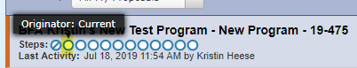
- If you click on the proposal’s row and then hover over the icon that looks like a sheet of paper, if it says “Edit Proposal” that means the proposal is on your step.

Before you can attach a document, you’ll need to click on the icon that looks like a sheet of paper to open the proposal in Edit Mode.
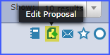

On the right side of the screen, you’ll see the heading Proposal Toolbox in the dark purple section at the top of the page. In the row of icons below, look for the Files icon – it looks like a sheet of paper with a green plus sign:
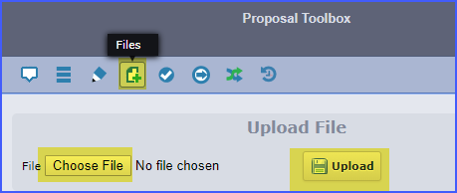

Inside the files area, click the Choose Files button to browse for the desired file on your computer. And once you’ve selected the file, click the Upload button on the left. Afterwards, your file will show below in the list of attached files.

If you ever wish to delete an attached file, you can click the X symbol that appears next to it, if you hover your mouse near the file name

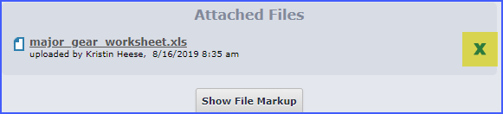.

Click here to return to Table of Contents.

Adding a Comment
Before you can comment on a proposal, you’ll need to click on the icon that looks like a sheet of paper to open the proposal in Edit Mode. If you don’t see “Edit Proposal” show up and only see “View Proposal” that means the proposal is currently not editable by you because it’s on someone else’s approval step.

After you’ve clicked the Edit Proposal button, you should see the full proposal show up, with the Proposal Toolbox on the right side of the screen. Directly below the Proposal Toolbox heading, you’ll see a list of icons – look for the icon that looks like a speech bubble to view/add comments:
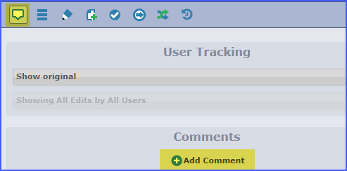

And then click on the Add Comment link to type and add your comment. Please note: once a comment has been added, it cannot be removed.

Click here to return to Table of Contents.

Making a Decision
When your proposal is open in Edit mode (click here if you need instructions on opening a proposal), you’ll be able to review the proposal information and make a decision in the Decisions area on the right side of the page, which you can access by clicking on the Check Mark Icon.
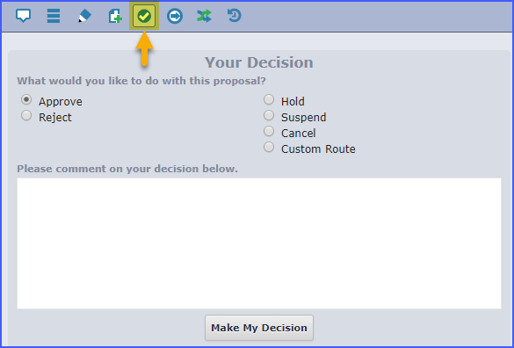

- If you approve a proposal, it’ll move on to the next step in the approval process.
- If you reject a proposal, it will go to the previous step in the approval person, and the person (or people) in that step will be able to edit the proposal, add/remove attachments, and approve the proposal when it’s ready to move on back to you, or they can reject it again to go to the prior step.
- If this proposal needs to go to someone else, you can also Custom Route it to another Curriculog user for editing & approval. This is useful, for example, if multiple departments are working on the same proposal. (Click here to read about how to Custom Route.)

If you want to see what’s left in the approval process, you can see the proposal’s current status, which steps have been completed, and which steps remain in the Status area of the Proposal Toolbox, on the right side of the page.
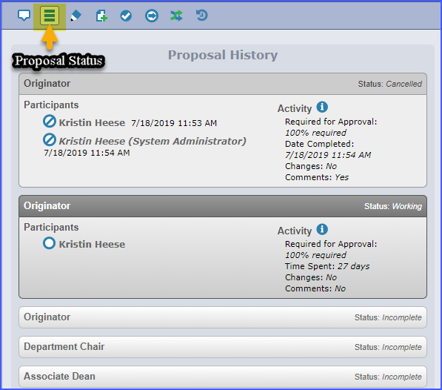

Custom Routing
*Note: this process can be fairly involved, so we don’t recommend it for beginner users. Contact the Curriculum Coordinator at ext 4193 if you need help routing your proposal to another person.

You can use Custom Routing to send the proposal to another person before you make your decision. For example, if you’re working on a New Course Proposal that’s a collaboration between multiple academic departments, you’re only allowed to list 1 department for the course. . . but you’d like to send it to the other department’s Chair for review. In this case, you’d want to Custom Route your proposal to that Department Chair before you’ve made a decision. (One you’ve made a decision, the proposal will be re-routed to another step, and you will likely have missed your chance to custom route it yourself.)

In order to custom route, the proposal must be on a step in which you participate. Locate the proposal (either in My Tasks or by Advanced Filtering to find it), and click the icon that looks like a piece of paper to open it in Edit mode.
Go to the Decisions section, which you can access by clicking the button that looks like a check mark, found on the upper right side of the screen in the Proposal Toolbox area.

Click the radio button for Custom Route, and then click the button to Make My Decision.
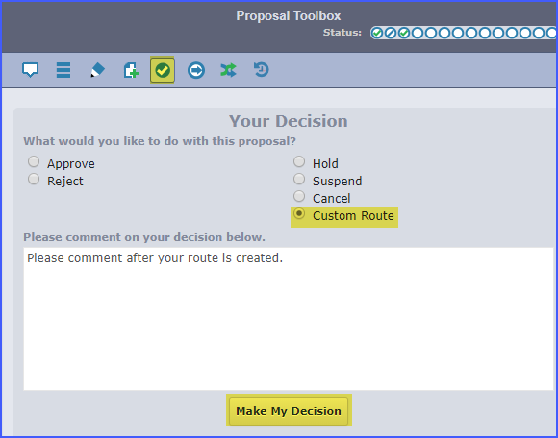

This will open up a new section titled My Pending Custom Route. You’ll need to carefully select your desired options:
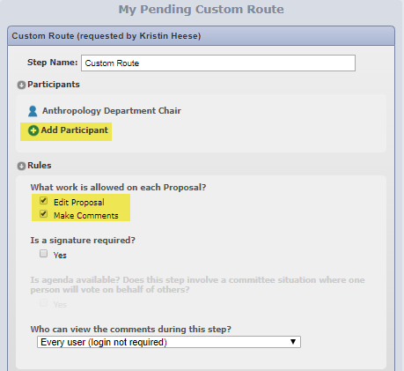
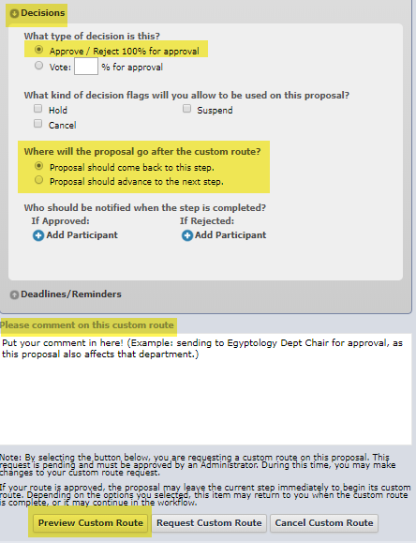

Here are your options and recommended choices:

- Add Participant: this one can be a little tricky. The person you add needs to already have a role in Curriculog for this to work. (If you’re stuck and don’t know how to proceed, contact the Curriculum Coordinator at ext 4193).
  - To find and add the person, click the Add Participant link and select: Hierarchy > Humboldt State University. From there, you will need to drill down in the correct category to find the person or role you’re looking for. Once you’ve found the person you want to add, click the Add Role(s) button.
  - For example, if I wanted to route this proposal to the Anthropology Chair, here’s the path I’d take: Hierarchy > Humboldt State University > College of Arts, Humanities & Social Sciences > Anthropology > Anthropology Department Chair. (You don’t need to click on the person’s name – in fact, we don’t recommend doing that, in case the Dept Chair changes while your proposal is in-process.)
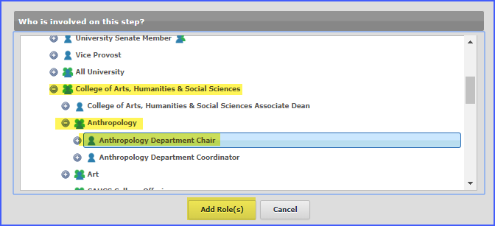
- Rules:
  - You can specify whether you want the person to be able to Edit Proposal (which will allow them to change proposal field text in Curriculog and add/remove attachments) and/or Make Comments.
  - If you’re collaborating with someone, we recommend checking both boxes for Edit Proposal and Make Comments. A note about editing: if you’re worried about somebody changing key information in your proposal, please keep in mind that Curriculog tracks user changes, so you can easily tell who changed something and how it was changed. You can view user changes by going to the Comments area and choosing Show current with markup in the User Tracking drop-down.
  - Is a signature required? No. We don’t require actual signatures since the approval process electronically records who made the decision. Leave this box unchecked.
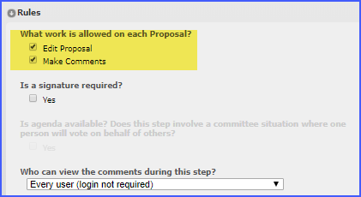
- Decisions:
  - This defaults to 100% approval to approve/reject, meaning everyone you list as a participant needs to approve the proposal before it moves on (this is the setting we recommend).
  - For “Where will the proposal go after the custom route?” If you want to review the proposal before it moves on (recommended), select Proposal should come back to this step. If no other actions will be needed from you, select Proposal should advance to the next step. In cases where multiple departments are collaborating, we recommend choosing Proposal should come back to this step, so that both departments’ approvals will be clearly noted.
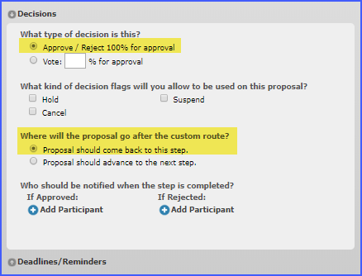

- Deadlines/Reminders: You don’t need to fill in anything here, unless you want to have extra automated reminder emails sent to bother the other person. (We don’t really recommend that.)
- Comment box: you can add a comment here about why you’re routing it. It’ll then show up on the Comments area once the custom route is complete.
- When you’re done, click the Preview Custom Route button. This gives you a chance to double-check that you’re routing the proposal as desired. Make sure that it shows that your person can edit and comment, if that’s what you want – you’ll see: Work: edit, comment
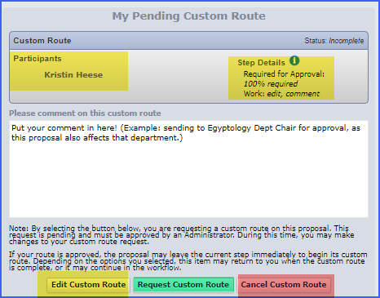
- If things don’t look right, you can go back and Edit Custom Route. If everything looks good, click Request Custom Route. Or if you want to, you can Cancel Custom Route.
- Please note: the custom route won’t be finalized and routed to the new recipient until it’s approved by a system administrator (usually the Curriculum Coordinator), so this process isn’t instantaneous.

Click here to return to Table of Contents.

